This remarkable image below shows you the elements on the periodic table classified based on their origins. This periodic table showcases mankind’s best estimation as to where each element comes from. Elements are subdivided into several categories based on where they originated from: The Big Bang, Cosmic Rays, Large Stars, Small Stars, Supernovae, and Man-Made labs.

At the very top, we have hydrogen. Hydrogen and helium are the only elements that (as you can see) are classified under the Big Bang. There are no other sources of this in the universe, thus, they are alone in this category. Let’s take a clear look at the image before moving on with the explanation:
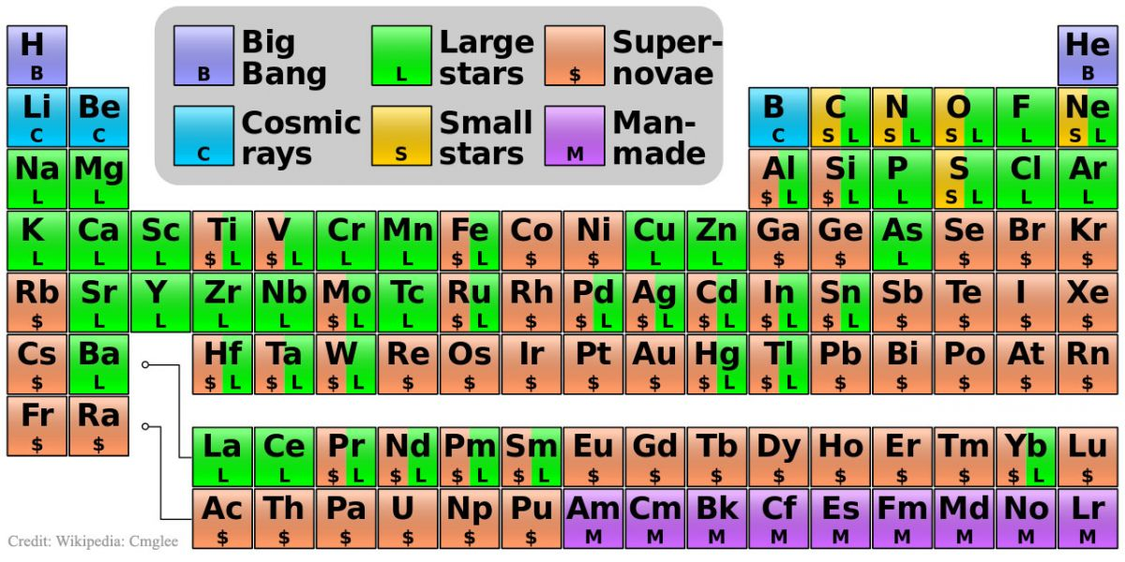
The carbon in your body was made by nuclear fusion in the interior of stars, as was the oxygen. Yes, that is right – you are the stuff of long dead stars. Much of the iron in your body was made during supernovae explosions…the fiery blasts of stars that could no longer support themselves and burst long ago and far away. But it doesn’t end there. The gold in your jewelry was likely made from neutron stars during cosmic collisions. It’s kind of cool when you think about it, you aren’t just star stuff; you are the the living remnants of massive, cataclysmic events….the walking, talking remains of the death of hypergiant stars. But then, so is your trashcan.

Interestingly, the periodic table, as we know it today, isn’t the first table of elements. In fact, we once believed that all things in the universe were made from just Earth, Fire, Water, and Air (thankfully, we didn’t stick with that organizational structure).

Most all naturally occurring elements on planet Earth have already been discovered, and the Periodic Table has been mostly filled in. Mostly. If a new element is discovered, it is generally the result of physicists smashing atoms together to see what happens i.e., a new element is only likely to be discovered in a particle accelerator.

- Watch “A Star Turns Inside Out” to review the information above
- For more information - check out Chem4Kids-Atoms
____________________________________________________________

Reflection:
Now that you have read the information above and watched the video, answer the questions below to bring the information together

- What are the two elements that originated from the Big Bang?

- Where does Carbon come from in the universe?

- How are stars formed? List the process by which they are created:

- When a star “dies” what happens to the elements inside of that star?

- What role does gravity play in the universe?

- In a few sentences, what is the gist of this article? (In other words, what is the main idea??)

